***План-конспект уроку***

***англійської мови в 7 класі***

***на тему:***

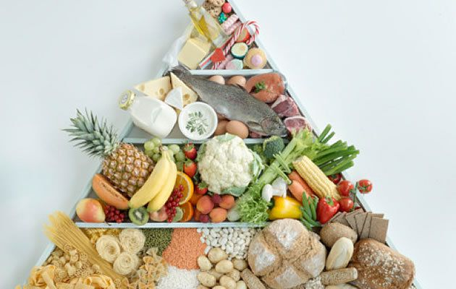***“Eat the right food”***

***Вчитель англійської мови***

***Соколівоцької ЗОШ І-ІІІ ступенів***

***Шинкарюк Валентина Миколаївна***

***Topic: Eat the right food***

***Мета***: повторити й закріпити вивчену з теми лексику;

розвивати навички всіх видів мовленнєвої діяльності учнів;

розвивати творчі здібності учнів, прагнення до самовдосконалення;

розвивати увагу, пам’ять, спостережливість, мислення.

***Обладнання:*** підручник, плакат “Foods”, картки з текстами та прислів’ями.

***Хід уроку***

***І. Підготовка до сприйняття іншомовного мовлення***

*1. Привітання*

T: Good morning, children! I am glad to see you. How are you? That’s good. I’m fine too, so we are ready to start our lesson.

*2. Оголошення теми та мети уроку*

T: Today we shall speak about food, one of the most essential part of our life. Food gives us energy and health and food sets us into a cheerful working mood. By the end of the lesson you’ll improve your skills in listening, reading and speakind and extend active and passive knowledge of vocabulary.

*3. Уведення в іншомовну атмосферу*

T: Рlease, read the proverbs and explain how you understand them.

“ An apple a day keeps the doctor away”

“ Live not to eat but eat to live “

“ Good health is above wealth”

***ІІ. Основна частина уроку***

1. *Активізація ЛО теми в усному мовленні*

T: Match the word-combinations with their translation

1. to be strong and healthy a) дотримуватися здорової/збалансованої дієти
2. to be active and lively b) їсти у визначені часи
3. to keep fit c) бути сильним та здоровим
4. to look good d) їсти жирну, гостру та солону їжу
5. to keep to a healthy/ balanced diet e) їсти багато солодкого
6. to eat at regular hours f) тримати форму
7. to have good eating habits g) добре виглядати
8. to eat a lot of sweets h) бути активним та жвавим
9. to drink fizzy drinks i) мати гарні кулінарні уподобання
10. to eay fatty, spicy and salty foods j) пити газовані напої

T: What should ( shouldn’t) we do to be healthy and strong?

*( suggested answers)*

* eat well, but not too much of the same food;
* drink a lot of water because it will keep your body healthy;
* eat lots of fruit and vegetables because they have a lot of vitamins which are important for your
* skin, bones and hair;
* eat too much junk food as hamburgers or pizzas, because they are bad for your health;
* drink too much tea or coffee because they will keep you awake at night;
* eat too many biscuits or chocolates because they full of sugar and are bad for teeth.

Do you eat at regular hours?

Do you take sugar in hot drinks?

How many sweets do you eat per week?

How often do you drink fizzy drinks, like Cola, Fanta or Sprite?

How often do you drink fresh fruit?

What do you eat during the breaks?

Do you eat fatty, spicy and salty dood?

1. *Warm up*

T: Today our fridge is full of products. Let’s look inside it and try to refresh a certain portion of lexic. React to the pictures using the expressions.

1. Thinking about _______ makes my mouth water.
2. _______ put(s) me in the right mood.
3. I prefer _______ .
4. It is so tasty to eat ______.
5. I adore _______ .
6. I would like to eat _______ .
7. I can’t stand _______ .
8. *Розвиток умінь аудіювання*

Ex.5,p.68

1. *Relaxation*

T: I’ve got a very funny rhyme for you. We’ll finish the lines like real poets. Are you poets? Let’s see! Which is the main thing in the poem? Right you are. It’s a rhyme. Let’s try to find it together.

|  |
| --- |
| juice, macaroni, tea, spaghetti, ham, coffee |

I am Sam. I like … (ham)

I am Bruce. I like …(juice)

I am Sophie. I like …(coffee)

I am Tony. I like …(macaroni)

I am Betty. I like …(spaghetti)

I am Lee. I like …(tea).

1. *Розвиток умінь читання*

T: Read and say why “sandwich” is called so.

an earl [ з:l ] – граф

to play cards

to remaine [re'mein] – залишатися

a servant ['sз:v(ə)nt] -- слуга

to continue [kən'tinju:] – продовжувати

to invent [in'vent] – винаходити

The ***Earl*** of Sandwich was an English­man. He lived in the eighteenth centu­ry. He was fond of ***playing cards*** so much that people knew him to be the greatest player in London. He played cards during the day and even didn't stop for his games at night. He ***remained*** at the table for twenty-four hours a day and even didn't stop for meals. His ***servant*** usually brought him some slices of meat and bread. So he was able ***to continue*** playing while eating.

It happened that the Earl of Sandwich put the meat between the bread and in this way ***invented*** a new dish. People began to call it "sandwich" after this man.

***Say if you agree or disagree with the sentences and explain why using the text.***

1. The Earl of Sandwich was a French­man.
2. He was fond of playing cards.
3. People knew him to be the greatest sportsman in London.
4. The Earl of Sandwich could play cards for twenty-four hours a day.
5. The famous player stopped playing only for meals.
6. People called a new dish after the Earl of Sandwich.

6. *Stripped conversation*

Work with the dialogues. The dialogue is written on the strips. Put the strips in the correct order and read the dialogue.

Examples

1. — How do you like your coffee?

* Would you like it black or white?
* White coffee, please.
* How many lumps of sugar?
* No sugar, thank you.
  1. — What are you going to have for break­fast?
* I like eggs very much.
* How would you like them soft-boiled or hard-boiled?
* Soft-boiled, please.

1. — What are you going to have for dessert?

* Ice-cream, please.
* Chocolate or vanilla?
* Vanilla, please.

1. — What can I do for you?

* I would like to take chicken soup for the first course.
* And for the second course?
* French fries, please.
* Any dessert?
* No dessert, please.
* Any drinks?
* Green tea and mineral water.

7. *Grammar task*

T: Open the brackets and use the correct form of the verb.

1. My father (to cook) meals every Sunday.
2. The boy (to eat) an apple now.
3. We usually (to drink) orange juice in the morning.
4. They (to have) a birthday party last Saturday.
5. I (to have) lunch break at one o’clock tomorrow.
6. We (to make) a huge cake now.
7. My friends (to go) to McDonald’s tomorrow.

***III. Заключна частина уроку***

1. *Пояснення домашнього завдання*
2. *Підсумки уроку.*

Our lesson is coming to its end . You have coped with all the tasks very well. All of you were well-prepared and active. I enjoyed your work at the lesson. You got such marks…